Date 23/3/23  
Name: Muqaddas Fatima

**Data Engineering Track  
Week 2 Task 5**

**Data types in SQL:**

Data types in SQL define the type of data that can be stored in a column of a table. The type of data affects the storage requirements and how the data can be manipulated. Some common data types in SQL include:

* INTEGER: used to store whole numbers
* VARCHAR: used to store variable-length character strings
* DATE: used to store dates
* DECIMAL/NUMERIC: used to store fixed-precision numbers with a specified number of digits to the left and right of the decimal point.
* FLOAT/REAL: used to store approximate numerical data with a specified number of digits and decimal places.
* CHAR: used to store fixed-length character strings.
* TEXT: used to store variable-length character strings with a very large maximum size.
* BOOLEAN: used to store boolean values (true/false).
* TIME: used to store a time of day value.

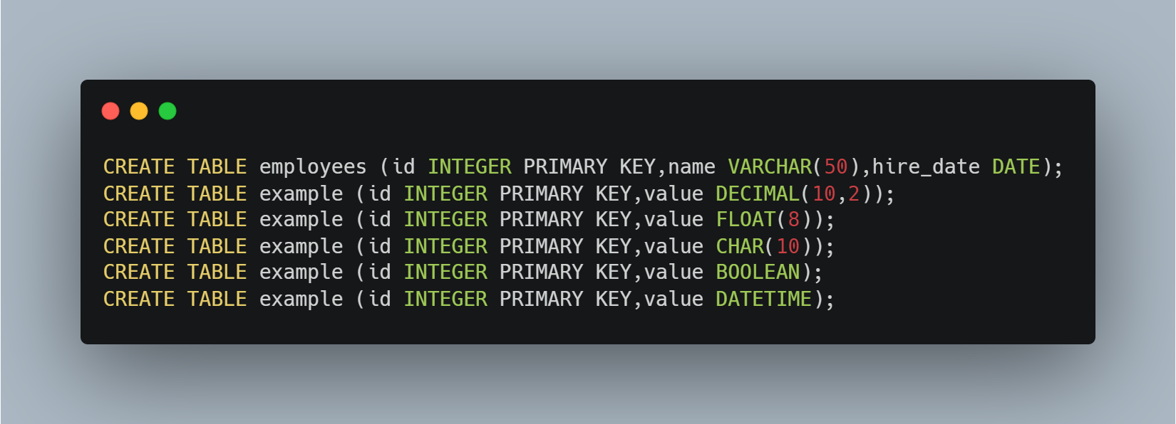

**SQL Constraints:**

SQL constraints are used to enforce rules and limitations on the data in a table. Some common types of constraints are:

* NOT NULL: ensures that a column cannot have null values.
* UNIQUE: ensures that each value in a column is unique.
* DEFAULT: specifies a default value for a column if no value is provided.
* CHECK: ensures that the values in a column meet a specific condition.
* PRIMARY KEY: a combination of NOT NULL and UNIQUE constraints that uniquely identifies each row in a table.
* FOREIGN KEY: ensures that the values in a column match the values in another table's primary key.

